**To study the relationship between economic policy uncertainty and investor sentiment on the return of the stock market in UK**

**Introduction**

This chapter will provide an overview of the research topic, including an introduction and context on the relationship between Economic Policy Uncertainty (EPU) and investor sentiment on the stock market's return.

The primary focus of this research will be on a few major areas of study, the first of which is the study of Economic Policy Uncertainty (EPU). EPU is concerned with the analysis of policy uncertainty in the context of economic risk, and its establishment has given economists a better understanding of how to forecast the uncertainty that is increasing the risk to businesses and individuals in terms of future spending and investment (Liao et al., 2019).

On the other hand, investor sentiment is also another part of the study for this research which refers to investor’s behaviour on how they react based on the changing in the economy and the market situation (Balcilar et al., 2018). The study on investor sentiment certainly is very subjective but critical in understanding the investor decision in the market or investment return. Previous study suggested that the investor sentiment with investor becoming more conservative, especially in facing the uncertainty or the risk predicted to increase, which could potentially lead to the impact on the future stock market (Greenwood and Shleifer, 2014).

The importance in understanding the relationship between EPU and investor sentiment towards the market return had led to the motivation to the research topic (Aye, 2018). Furthermore, the exploration of the market for this similar topic of research in related to the EPU index and the investor sentiment had been covering most of the popular and major market which indicates that there is a lack of study to understand on the smaller market as the output and result may not be similar in comparison with major market due to the high influential factor for the major market (Liao et al., 2019). This will also create the motivation for further knowledge exploration which could be providing useful information for future researchers. This will be crucial to future analyses on how the investor sentiment and the EPU will influence against the return on the stock market in UK as most of the previous study is emphasizing on the major market which is like US and China where the series of study had been conducted (Liao et al., 2019). The reference of the previous research will be use as the guideline to further this research topic which to added value to further research for this area.

With this, the general idea of this research topic certainly create an overview on the research direction where the research question and research objectives had been drawn to align the topic of research and achieving the goal from this study on research.

**Research Question**

1. What is the relationship between EPU and return on stock market?

2. What is the relationship between investor sentiment and return on stock market?

3. Is there any valid relationship between the EPU, investor sentiment and return on stock market?

In this research topic, the background of this study will be provided before defining the problem statement and the motivation for this topic of research. The research questions and research objectives are also provided in order to in this chapter to provide the overview on the direction and goal for this research.

Next, the study on the previous research and journal articles will be conducted where the discussion on the literature review will be summarized and critically analysed. The positive and negative literature review will help to sum up the argument and conclude the theoretical framework and the hypothesis for this research topic. The methodology part followed, will provides the overview on the research design for this quantitative analysis where the proposed testing and sampling will be provided. The measurement of the data will also be identified on this chapter determine the data collection approach to be conducted for this research before moving to the analysis part.

**Literature Review**

Investor Sentiment

Investor sentiment is a controversial factor in the theory of finance and investment as the investor sentiment reflects on the investor behaviour which is a human factor as this human nature is defined as reacting based on the evolving current situation or event (Kim et al., 2019). Therefore, it is subjective to judge on the investor sentiment especially against the return of the stock market. Lu et al. (2012) had mentioned that there is significant existence of the relation between the investor sentiment and the return of stock market. The research had been emphasizing on the Chinese stock market where the study was based on newly opened stock account and the observation is significant showing that the reaction of the stock prices increases or decreasing more when the market becoming bullish or bearish depending on the investor sentiment theory (Lu et al., 2012).

The same concept is being study against the US market where US market is considered as one of the significant markets that impact the global economy. The outcome signals that the stock returns are strongly affected by the investors sentiment which shows a very strong positive relationship between the two variables. In addition, the study also studies on the monetary policy which is also part of the contribution that affects the return of the stock market (Yildirim et al., 2018).

In another area of research, the investor sentiment is tested within the Europe market like UK, Spain, Germany and France to check whether does the investor sentiment will affect the return on stock price and the result is also positive on the stock characteristics very relevant to explain the effect of the investor sentiment towards the stock return (Corredor et al., 2013). The focus of the European market to study the investor sentiment is because that the European market is very big to define the level of financial development which European market is deemed to be one of the major markets in the global as well (Yildirim et al., 2018).

This also suggested that with different market from country specific, the outcome for the investor sentiment is predicted to be the same and affecting the stock prices and return as well slowly creating the assumption that this concept could be positive for all country specific market (Lao et al., 2018). With these findings, the positive outcome seems to be very positive with the prediction of the strong relationship between the investor sentiment and the return of stock market creating the expectation of the same output for this research.

Economic Policy Uncertainty (EPU)

The economic policy uncertainty is something very common from the economics perspective in defining the uncertainty index for the economy like recession and boom (Goel et al., 2021) and this measurement will help to predict the next steps in building up the economy using both monetary and fiscal policy (Christou et al., 2017). The prediction of the uncertainty is basically being calculated based on the adjusted GDP to reflect the Global EPU Index. Based on one research on the EPU, Phan et al. (2018) concluded that their research on the EPU had found strong evidence that showed the strong relation on that the return of the stock market can be predicted with reference to the EPU and this means that the EPU holds a significant impact towards the return of the stock market. The test of the concept had been done in few different countries to cover multiple types of market and where the positive result had been concluded for majority of the countries involved for the testing naming Australia, China, India, UK and US for some of the examples (Phan et al., 2018).

There is also another study for the EPU scope where the relation of EPU with the stock market was tested. The result turned to be positive but there is only a detection of weak relation between the two where the analysis concludes this is due to the available risk and uncertainty with the increasing of the EPU index (Li et al., 2016). The EPU index is heavily being influence with the government policy or sometimes is being referred as the monetary and fiscal policy which act as the steps of controlling the economy (Arouri et al., 2016). This showed that there is an inconsistency of the strength of the positive relation within the study for the EPU factor affecting the stock market (Li et al., 2016).

However, in another research conducted for the Japanese market, Chiang (2020) had mentioned that there is presence of the negative correlation between the EPU and the return of the stock market which disagreed with other research. It is identified that the increase of the volatility in terms of risk and uncertainty will produce a negative impact on the stock return where the EPU indicates similar signal to the market which probably could been the factor (Li et al., 2016). This similar concept was agreed on a separate research done for the Turkish market where the greater level of uncertainly will produce negative correlation for the stock return (Demir and Ersan, 2018). This means that EPU will be influencing the stock return but in an opposite direction.

It is understood that the reasoning was due to the uncertainty and risk where the investor and market will become more pessimistic towards the market potential or being more bearish confidence towards the market when the EPU Indices rises (Christou et al., 2017). This impact of the EPU had certainly negative mindset towards the investor and market confident level as the higher the EPU index will interpret that the economy is not stable risking the possibility that stock market may not be doing well (Liao et al., 2019).

Return of the Stock Market

The stock market return is often referred as the return on investment is one of the major parts of the study as there are multiple possible factors that can bring the different in impacts towards the return of the stock market (Er and Vuran, 2020). There are many possible factors that can influence the return of the stock market which include the investor sentiment and the EPU index that will be part of the study for this research topic. Investor sentiment had been very subjective factor, but many researchers suggested that the investor sentiment is highly influencing the return for the stock market which was proven in some of the study and research (Lao et al., 2018).

The investor sentiment is believed to be one of the determinant factors against the return of the stock market because the investor behaviour in investing will put the pressure on the pricing and return of the stock market (Ryu and Yang, 2017). The conception of the bullish and bearish market serves as the trigger point for the investor to make their investment decision (Ruan et al., 2018).

The return of the stock market return had been studied on major markets like United States, United Kingdom, Japan, Hong Kong but not on smaller countries like Singapore, Cambodia, Malaysia, Indonesia (Shen et al., 2017) and so on which could be the less potential area of study for the research. The study on the major market certainly will provide more significant data and information to the study of the research but it does not confirm on the concept to be applied for all the countries provided the different environment and situation. Corredor et al. (2013) conclude the research on the investor sentiment effect on stock markets from the European market had provided a broad research covering major Europe markets where the findings manage to conclude not all the findings are agreeing with one answer which reflect the possibility of the country specific factor to have influence on this investor sentiment factor as the conclusion was summarize in general agreeing on the investor sentiment will have positive correlation and relation with the return of the stock market.

Furthermore, the study between the return of stock market with the EPU certainly is an interesting topic as some researchers are having multiple concept and conclusion regarding this area of study. Chang (2020) suggested that the EPU index will move negatively correlated against the return of the stock return in his study of research but in some other findings did suggested that the stock price and EPU is sharing the same positive behaviour based on the movement of the EPU index and stock price (Phan et al., 2018).

These different in suggestion did put doubt on the EPU index is having positive or negative relation against the return of the market and the research so far only focusing on the market that are included as part of the Global EPU Index as there is lack of exploration for the market that does not has the country’s GDP being contributed to the Global EPU Index as the result and output may provide different in suggestion (Yildirim et al., 2018). The increase of the EPU index indicates the uncertainty of the investment in stock market which makes more investor more conservative on the return as the high-risk high return theory may be attractive but only if investor is on the winning side which is high unlikely (Greenwood and Shleifer, 2014).

**Methodology**

The data collection will focus on 10 years’ timeline from 2011 to 2020 focusing on the UK market index in the London Stock Exchange (LSE) comparing with the data on the UK EPU index and the trading volume in the LSE. The data collection will be on secondary data approach where the data is obtained through the available primary data through public website including Yahoo Finance for London Stock Exchange (LSE) index, Global EPU Index platform for UK EPU index and financial website for investor sentiment. In addition, in order to control the potential impact of various macro indicators on the model, using the Consumer Price Index (CPI), and Treasury bond yield ($R_{f}$) as control variables.

**Data Obtaining and Preprocessing**

We use the consumer confidence index (CCI) of the United Kingdom as a measure of investor sentiment based on previous studies. Based on responses to questions about their anticipated financial condition, their sentiment about the general economic situation, unemployment, and savings capability, the consumer trust indicator predicts future trends in household consumption and saving. An indicator above 100 indicates that consumers are more optimistic about the potential economic situation, and as a result, they are less likely to save and more likely to spend money on big purchases in the coming year. Indicator below 100 reflect a negative outlook on potential economic developments, likely leading to a desire to save more and spend less.

Meanwhile, the official website of economic policy uncertainty will be used to collect the EPU index. The index is focused on articles in newspapers about policy uncertainty. The Times, The FT, The Telegraph, Sunday Times, The Guardian, The Daily Mail, The Mirror, The Daily Express, The Sun, The Evening Standard, and The Northern Echo are among the 11 UK newspapers represented. The phrases uncertainty, economic or market, and policy related terms are used in the news articles, and ‘tax’, ‘ regulation’, ‘spending’, ‘ policy' are words that are applicable to policy.

The FTSE 100 index is an index of the 100 largest companies listed on the London Stock Exchange as the representative of the return of stock market in UK. The index is a barometer of the British economy and one of the most important stock indexes in Europe. The return of stock market is measured by the increase or decrease of the index in a monthly period.

As for the collection of control variables, CPI index will be collected as one of them, a macroeconomic indicator that reflects changes in the price level of consumer goods and services generally purchased by households, to represent the influence of social economic influencing factor to stock return. Besides, according to the Capital Asset Pricing Model (CAPM), relationship exerts between systematic risk and expected return for assets, and this is particularly common when it comes to the measurement for the return of stocks. Therefore, the return of a risk-free bond (systematic risk) should also be considered as a control variable and I obtain the annual yield of the UK treasury bond to act as the systematic risk in the research.

The regression test will be including in the research methodology as this is crucial in explaining the phenomena of the significant relationship of the independent variable in EPU index and investor sentiment against the dependent variable in the market return (Demir & Ersan, 2018). The stepwise regression model will be used to predict the value of the dependent variable and estimate the effect of some explanatory variable on the dependent variable. The proposed research methodology will emphasize on the use of Rstudio software in generating the statistical data that will help in interpretation and hypothesis testing to draw the finding for this research.

**Regression Model**

The establishment of the regression model will refer to the research of Rehman and Apergis (2019).

$R_{t}=β_{0}+ β_{1}CCI+β_{2}EPU+β_{3}CPI+β_{4}R_{f}+ε$.

(Rehman and Apergis, 2019)

$R_{t}$*refers to the monthly return rate of the FTSE 100 index; CCI refers to consumer confidence index (investor sentiment); EPU refers to economic policy uncertainty; CPI refers to Consumer Price Index and $R_{f}$ refers to* *Treasury bond yield.*

Dependent Variable

Independent Variable

Economy Policy Uncertainty Index

Return on stock market

Investor Sentiment

**Descriptive Data Analysis**

**Table 1(empirical data)**

|  |  |  |  |  |  |  |  |  |  |  |
| --- | --- | --- | --- | --- | --- | --- | --- | --- | --- | --- |
| Variable | Min | Max | Median | Mean | Std | 1th Qu | 3rd Qu | Range | Skew | SE |
| $$EPU$$ | 62.34 | 558.22 | 148.92 | 163.50 | 76.38 | 115.22 | 192.49 | 495.89 | 2.17 | 6.97 |
| $$CPI$$ | 99.5 | 128.5 | 113.05 | 115.13 | 10.37 | 105.8 | 126.0 | 29 | 0.01 | 0.95 |
| $$CCI$$ | 95.62 | 102.62 | 100.35 | 99.57 | 2.13 | 97.18 | 101.10 | 6.99 | -0.43 | 0.19 |

**Table 2(standardized data)**

|  |  |  |  |  |  |  |  |  |  |  |
| --- | --- | --- | --- | --- | --- | --- | --- | --- | --- | --- |
| Variable | Min | Max | Median | Mean | Std | 1th Qu | 3rd Qu | Range | Skew | SE |
| $$EPU$$ | -0.48 | 1.12 | 0.05 | 0.05 | 0.31 | -0.21 | 0.24 | 1.61 | 0.89 | 0.03 |
| $$CPI$$ | -0.23 | 0.01 | 0.00 | 0.00 | 0.02 | 0.00 | 0.00 | 0.24 | -10.31 | 0.00 |
| $$CCI$$ | -0.01 | 0.00 | 0.00 | 0.00 | 0.00 | 0.00 | 0.00 | 0.02 | -1.46 | 0.00 |
| $$R_{f}$$ | -0.04 | 0.8849 | 0.41 | 0.42 | 0.22 | 0.28 | 0.55 | 0.93 | -0.06 | 0.02 |
| $$R_{t}$$ | -0.14 | 0.12 | 0.01 | 0.00 | 0.04 | -0.02 | 0.02 | 0.26 | -0.38 | 0.0 |

According to the Table 1. Out of three indexes, CCI have the most steadily changes during the year with a 2.13 standard deviation and 6.99 range. CPI is close with 10.37 standard deviation and 29 range. We can see that EPU goes through tremendous fluctuation during the ten years, with a mean of 163.50 and a standard deviation of 76.38.

Based on Table 2. CCI have the least standard deviation with a 0.00 and mean of 0.00. CPI and Rt are close with a 0.03 and 0.04 standard deviation with a mean of 0.00. EPU and Rf have the most fluctuation with a standard deviation of 0.31 and 0.22 with a mean of 0.05 and 0.42 mean.

Figure 1Density plot

According to the plot of the density distribution of EPU, as shown in Fig1, it shows that the median is smaller than mean, and it is a positive-skewed distribution, that is, the skewness coefficient is larger than 0, which is also called left-skewed. As for CCI, the mean is smaller than the median, and it is a negative-skewed distribution, the skewness coefficient is less than 0, which is also called right-skewed. CPI Rt, and Rf have the Skewness close to zero so we say that the distribution of CPI Rt, and Rf are close to normal distribution.

Figure 2 Return Rate of two Capital Assets

Figure 2 indicates that the return of the FTSE 100 index fluctuated slightly around 0. However, the annual yield of the UK Treasury Bond behaves the opposite. It dropped from 0.9 in 2011 to 0.2 around mid 2012, then fluctuated around 0.4 between 2013 and 2016. Afterwards it went from 0.2 in 2017 to 0.8 in 2018 in a sudden. Finally it had a second major drop during late 2019 to early 2020.

**Pearson Test**

|  |  |  |  |
| --- | --- | --- | --- |
|  | t | p-value | Correlation |
| EPU | 7.0954 | 1.004e-10 | 0.5452451 |
| CCI | -1.039 | 0.3009 | -0.094814 |
| CPI | -0.68989 | 0.4916 | -0.06311563 |
| $$R_{f}$$ | 6.3202 | 4.719e-09 | 0.5013136 |

|  |  |  |  |  |  |
| --- | --- | --- | --- | --- | --- |
|  |  | EPU | CCI | CPI | $$R_{f}$$ |
| $$R_{t}$$ | 1 |  |  |  |  |
| EPU | 0.54524513 | 1 |  |  |  |
| CCI | -0.09481488 | -0.04781042 | 1 |  |  |
| CPI | -0.06311563 | 0.05956421 | 0.79072931 | 1 |  |
| $$R_{f}$$ | 0.50131358 | 0.09650454 | -0.18550843 | -0.04696916 | 1 |

Through covariance analysis, it can be concluded that the correlation coefficients of EPU, CCI, CPI and $R_{f}$ are 0.54524514, -0.09481488, -0.06311563, 0.50131358. EPU and $R_{f}$ have positive correlation with $R_{t}$ while CCI and CPI have negative correlations. CCI has negative correlation with EPU while CPI and $R_{f}$ have positive correlations.

**Unit root Test**

|  |  |  |  |  |  |
| --- | --- | --- | --- | --- | --- |
|  | $$R_{t}$$ | EPU | CCI | CPI | $$R_{f}$$ |
| ADF/Dicky-fuller | -4.71 | -2.2438 | -4.1766 | -3.403 | -4.8326 |
| lag order | 4 | 4 | 4 | 4 | 4 |
| p-value | 0.01 | 0.4753 | 0.01 | 0.05739 | 0.01 |

|  |  |
| --- | --- |
| Null Hypothesis | Alternative Hypothesis |
| H0 *– There is a unit root* | H1 *–* The time series is stationary |

Since only the P-value of EPU and CPI are larger than 0.05 and the other three variable is smaller than 0.05, we are going to say that we fail to reject the null hypothesis of EPU and CPI. We reject the null hypothesis for Rt/Rf/CCI. Therefore, the P-value is less than 0.05, indicating that the null hypothesis is rejected at the significance level of 95%, that is, the original sequence does not contain unit roots, and the data is stable.

**Regression Analysis**

1. Multiple Linear Regression between Rt and EPU, CCI, CPI and Rf

Multiple Linear Regression analysis was performed between Rt and EPU, CPI, CCI, $R_{f}$. The model was stated as below:

$$R_{t}=β_{0}+β_{1}{EPU_G}_{t}+β_{2}{CPI_G}_{t}+β_{3}{CCI_G}_{t}+β_{4}R_{f}+ε .$$

The hypothesis test was stated as following:

|  |  |
| --- | --- |
| Null Hypothesis | Alternative Hypothesis |
| H0*: There is no correlation between EPU, investor sentiment and return of stock market*. | H1: *There is a positive correlation between EPU, investor sentiment and return of stock market*. |

The regression results are shown as following:

> summary(model)

Call:

lm(formula = Rt1 ~ EPU1 + CCI1 + CPI1 + Rf1, data = data1)

Residuals:

Min 1Q Median 3Q Max

-0.5361 -0.1371 0.0277 0.1345 0.4182

Coefficients:

Estimate Std. Error t value Pr(>|t|)

(Intercept) -4.722845 0.733061 -6.443 2.78e-09 ***

EPU1 0.042667 0.005339 7.992 1.09e-12 ***

CCI1 0.631954 0.342929 1.843 0.0679 .

CPI1 -0.005706 0.002660 -2.145 0.0340 *

Rf1 0.032966 0.004595 7.175 7.34e-11 ***

---

Signif. codes: 0 ‘***’ 0.001 ‘**’ 0.01 ‘*’ 0.05 ‘.’ 0.1 ‘ ’ 1

Residual standard error: 0.191 on 116 degrees of freedom

Multiple R-squared: 0.5197, Adjusted R-squared: 0.5032

F-statistic: 31.38 on 4 and 116 DF, p-value: < 2.2e-16

The p-value for the F-statistics is < 2.2e-16, which means the model is highly statistically significant. This means that at least one of the four explanatory variables is significantly related to the responsive variable. Since the p value is smaller than 0.05, we reject the null hypothesis.

Multiple R-squared and Adjusted R-squared are 0.5197 and 0.5032 respectively, which indicate a acceptable fit of the data and model. Three explanatory variables have less than 0.05 p values while CCI have a p value that is slightly over 0.05. The p value of EPU(1.09e-12) and Rf(7.34e-11) is significantly smaller than CCI(0.0679) and CPI(0.0340). Three explanatory variables have positive estimate coefficients while CPI have an estimate coefficient that is slightly under 0.

In summary, changing in EPU and Rf are more significantly associated with changing in Rt while changing in CCI and CPI are slightly significantly associated with changing in Rt. EPU, Rf and Rf arepositively related with Rt while CPI is negatively related with Rt.

In this research, there is a positive correlation between EPU and UK stock market returns, which further proves the view of Phan et al. (2018), which means that EPU has a significant impact on stock market returns. However, we also found that the impact of CCI on stock market returns in the past ten years is weaker than that of EPU, which is also in line with expectations. According to Lee et al. (2003), they believe that investor sentiment will not have a significant impact on the stock market returns. However, this finding is controversial, because both institutional investors and uninformed investors invest in the same market. When research whether investor sentiment has an impact on market returns, both types of investors should be considered.

Assumption Check:

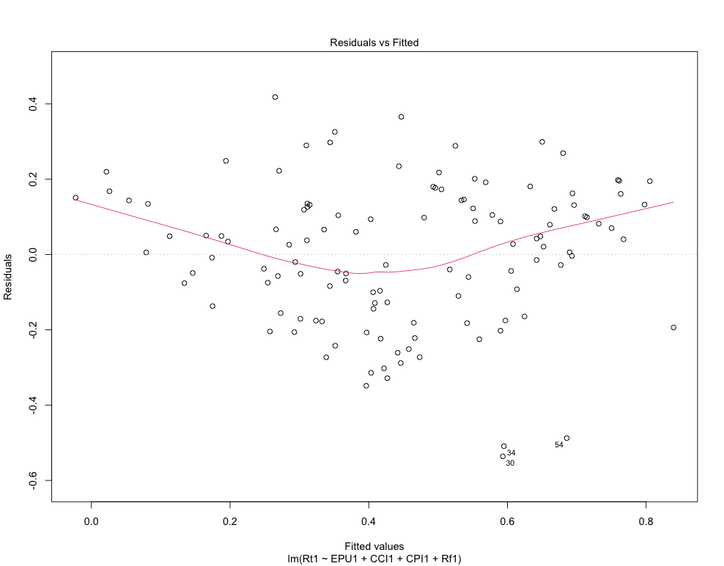

The “residuals vs fitted” plot as above indicates that no major fitted pattern is observed, that is the red line is approximately horizontal to zero. The assumption that the relationship between the predictor(EPU, CPI, CCI, Rf) and outcome(Rt) is linear is met.

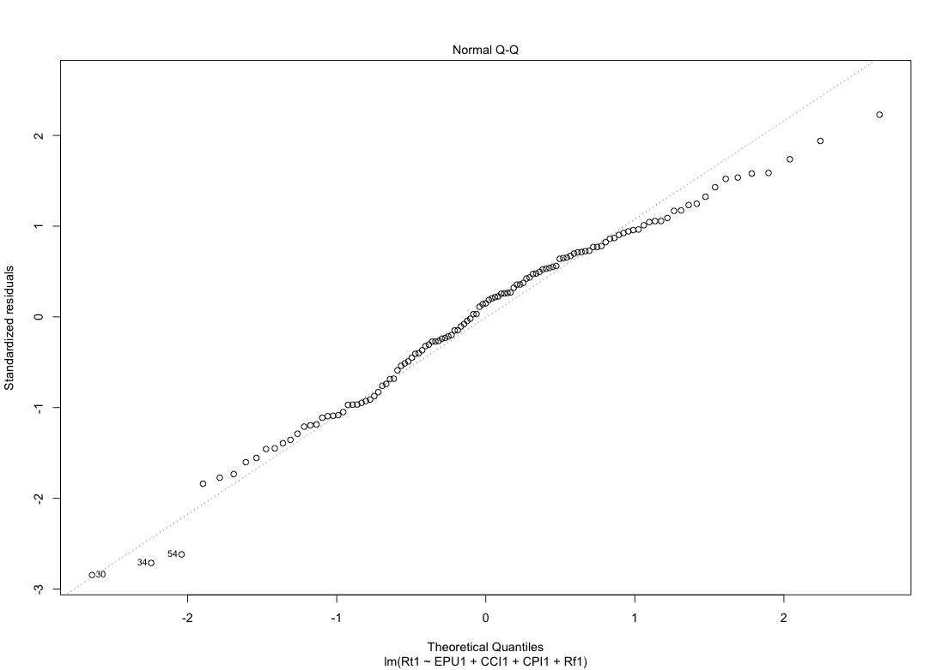

The QQ plot of residuals shown above is used to check the normality of residuals. As we can observe, the normal probability of residuals follows a straight line. The assumption that the residual errors are assumed to be normally distributed is satisfied with this multiple linear regression model.

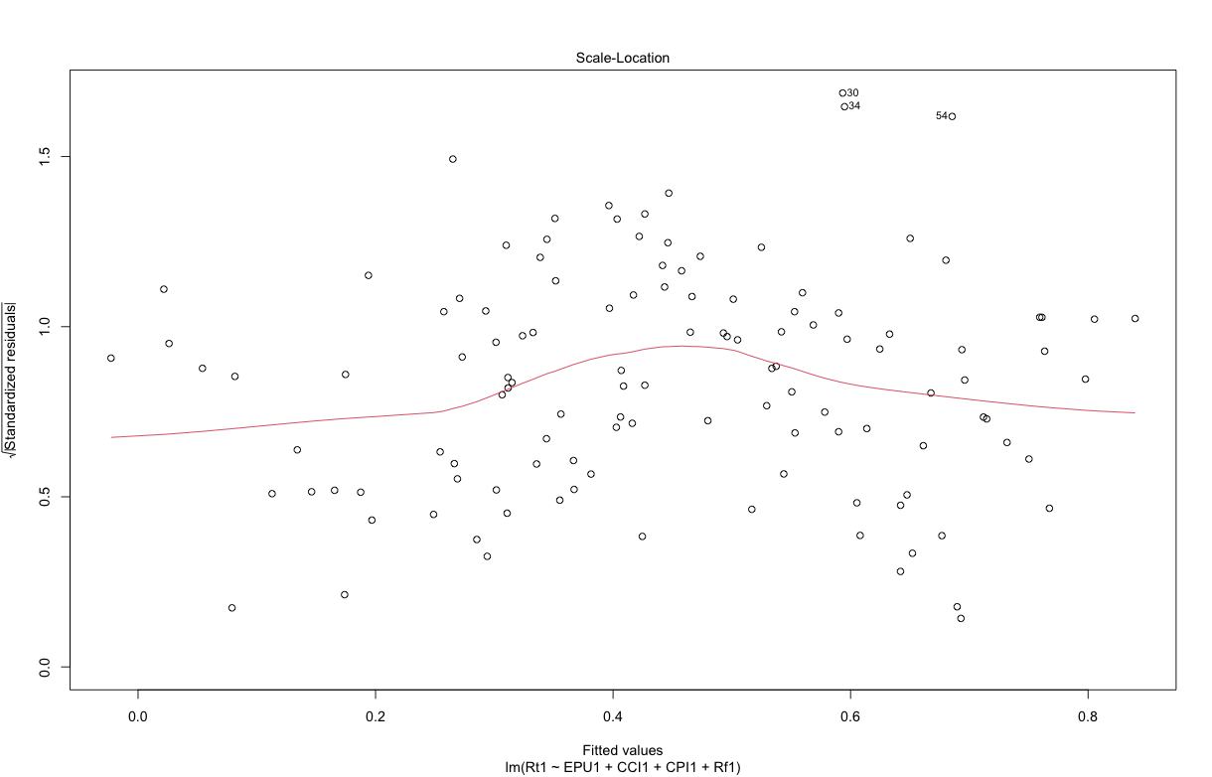

The scale-location plot, also called spread-location plot above can be used to check homogeneity of variance. This plot shows that the residuals are spread equally along the range of predictors. A nearly horizontal line with equally spread points is observed.

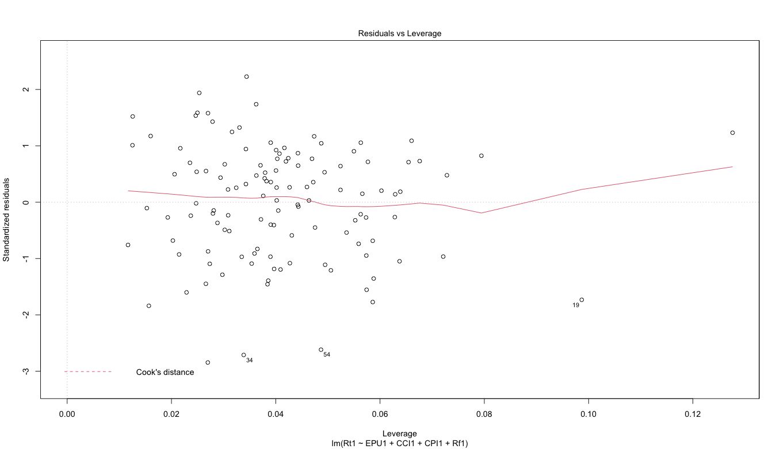

The “Residuals vs Leverage” plot above indicates that no extreme(Y axis absolute value greater than 3) variable values have been seen. Extreme predictor value x, also known as outlier, can be identified by standardized residual, which is the residual divided by its estimated standard error. Standardized residuals can be interpreted as the number of standard errors away from the regression line. Observations whose standard residuals are greater than 3 in absolute value are considered tow be possible outliers. Only 3 top most extreme point(#19,#34,#54) are shown but none of them exceed 3 standard deviations, which is good.

The plot also shows that no high leverage point in the dataset. That is, all point, have a leverage statistics below 2(p + 1)/n = 2(5 + 1)/121 = 0.099 (p is the number of predictors and n is the number of observations). Only two extreme points have exceed 0.099, which is good.

2. Simple Linear Regression Between Rt and EPU

Simple Linear Regression Model between Rt and EPU was performed. The equation was stated as below:

$$R_{t}=β_{0}+β_{1}{EPU}_{t}+ε$$

|  |  |
| --- | --- |
| Null Hypothesis | Alternative Hypothesis |
| H0 *- There is no significant relationship between EPU and return of stock market*. | H1 *- There is a significant relationship between EPU and return of stock market*. |

The regression results are shown as following:

Call:

lm(formula = Rt ~ EPU, data = ER_Final_Data)

Residuals:

Min 1Q Median 3Q Max

-0.57387 -0.13868 0.03098 0.17142 0.49304

Coefficients:

Estimate Std. Error t value Pr(>|t|)

(Intercept) -3.241855 0.520334 -6.230 7.28e-09 ***

EPU 0.044517 0.006274 7.095 1.00e-10 ***

---

Signif. codes: 0 ‘***’ 0.001 ‘**’ 0.01 ‘*’ 0.05 ‘.’ 0.1 ‘ ’ 1

Residual standard error: 0.2281 on 119 degrees of freedom

Multiple R-squared: 0.2973, Adjusted R-squared: 0.2914

F-statistic: 50.34 on 1 and 119 DF, p-value: 1.004e-10

The p-value for the F-statistics is 1.004e-10, which means the model is highly statistically significant. This means that explanatory variables are significantly related to the responsive variable. Since the p value is smaller than 0.05, we reject the null hypothesis. Multiple R-squared and Adjusted R-squared are 0.2973 and 0.2914 respectively, which indicate a bad fit of the data and model.

> ggplot(model1, aes(x=EPU, y=Rt)) +

+ geom_point() +

+ geom_smooth(method=lm)

+ ggtitle(“Plot of Simple Linear Regression between Rt and EPU”)

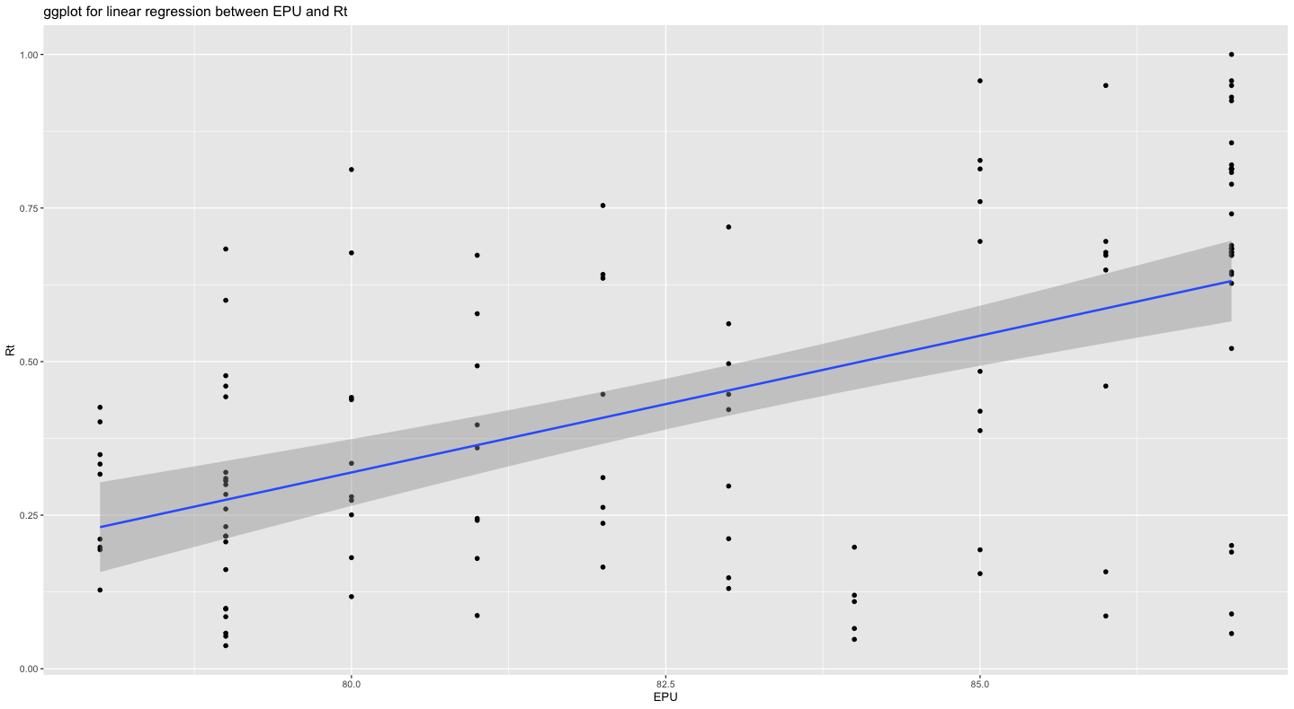

As the plot indicates, there is a slope that have a upward direction from lower left corner to upper right top. The range of Rt is between 0 and 1. The range of EPU is roughly from 75 to 90. Dots are scattered at an even level instead of a clustered type in the plot. Based on the regression result, the coefficient of EPU is 0.044517, it means that increase in one unit of EPU will result in 0.044517 increase in Rt. Thus, Rt and EPU have a positive correlation in this analysis.

3. Single Linear Regression Between Rt and Rf

Multiple Linear Regression Model of Rt and CCI/CPI was performed. The equation was stated as below:

$$R_{t}=β_{0}+β_{1}{Rf_G}_{t}+ε$$

|  |  |
| --- | --- |
| Null Hypothesis | Alternative Hypothesis |
| H0 *- There is no significant relationship between investor sentiment and return on stock market.* | H1 *- There is significant relationship between investor sentiment and return on stock market.* |

The regression results are shown as following:

> summary(model2)

Call:

lm(formula = Rt1 ~ Rf1, data = data1)

Residuals:

Min 1Q Median 3Q Max

-0.51369 -0.18110 -0.03541 0.23231 0.44127

Coefficients:

Estimate Std. Error t value Pr(>|t|)

(Intercept) -0.530367 0.156147 -3.397 0.000928 ***

Rf1 0.034617 0.005477 6.320 4.72e-09 ***

---

Signif. codes: 0 ‘***’ 0.001 ‘**’ 0.01 ‘*’ 0.05 ‘.’ 0.1 ‘ ’ 1

Residual standard error: 0.2355 on 119 degrees of freedom

Multiple R-squared: 0.2513, Adjusted R-squared: 0.245

F-statistic: 39.95 on 1 and 119 DF, p-value: 4.719e-09

The p-value for the F-statistics is 4.719e-09, which means the model is statistically significant. Since the p value is smaller than 0.05, we reject the null hypothesis. There is a significant relationship between Rt and Rf. Multiple R-squared and Adjusted R-squared are 0.2513 and 0.245 respectively, which indicate weak fitting pattern between the data and model.

> ggplot(model2,aes(x=Rf1, y=Rt1))

+ geom_point()

+ ggtitle("Scatterplot of RT against CCI")

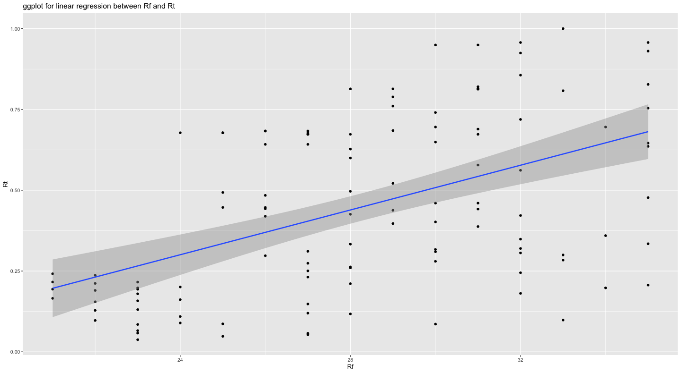

As the plot indicates, there is a slope that have a upward direction from lower left corner to upper right top. The range of Rt is between 0 and 1. The range of Rf is roughly from 20 to 36. Dots are scattered around the middle and right side of the plot. Based on the regression result, the coefficient of EPU is 0.034616, it means that increase in one unit of EPU will result in 0.0349617 increase in Rt. Thus, Rt and Rf have a positive correlation in this analysis.

**Conclusion**

From the multiple linear regression result, we can tell that EPU and Rf have way more statistically significant relationship with Rt since their p value are both way smaller than 0.05(1.09e-12 and 7.34e-11 respectively). CCI and CPI have less meaningful relationship with Rt as their p values are close to 0.05(0.0679 and 0.0340 respectively).

From the single variable linear regression result, we can learn that EPU and Rf correlated with Rt with a statistical significance. However, The multiple R-squared of both model are close to 0.25(0.2973 and 0.2513 respectively), which is lower than the multiple linear regression R-squared(0.5197). This indicates that Rt is more heavily correlated with EPU and Rf combined than individually. Additionally, a low R-squared score and small p value indicates that the relationship between Rt and EPU, Rf is not necessarily linear. More sophisticated model including logistic regression, polynomial regression can be used for further analysis.

In summary, Investor sentiment has less impact on the return of the stock market, but this is controversial and needs more research in the future to prove it. Economic Policy Uncertainty and treasury bond yield have way more significant relationship with the return of the stock market when compared to investor sentiment. Nevertheless, from the result of our model, the relationship between them is not necessarily linear. Further model including logistic, polynomial or other type of regression can be performed to determine the exact type relationship between return on stock market and economic policy uncertainty as well as treasury bond yield.

**References List**

Arouri, M., Estay, C., Rault, C. and Roubaud, D. (2016) ‘Economic policy uncertainty and stock markets: Long-run evidence from the US’. *Finance Research Letters*, 18, pp.136-141.

Aye, G.C. (2018) ‘Causality between economic policy uncertainty and real housing returns in emerging economies: A cross-sample validation approach’, *Cogent Economics & Finance*, 6(1), pp. 1473708.

Balcilar, M., Gupta, R. and Kyei, C. (2018 ‘PREDICTING STOCK RETURNS AND VOLATILITY WITH INVESTOR SENTIMENT INDICES: A ECONSIDERATION USING A NONPARAMETRIC CAUSALITY-IN-QUANTILES TEST’, *Bulletin of Economic Research*, 70(1), pp. 74 to 87.

Chiang, T.C. (2020) ‘Economic policy uncertainty and stock returns—evidence from the Japanese market’, *Quantitative Finance and Economics*, 4(3), pp. 430-458.

Christou, C., Cunado, J., Gupta, R. and Hassapis, C. (2017) ‘Economic policy uncertainty and stock market returns in PacificRim countries: Evidence based on a Bayesian panel VAR model’, *Journal of Multinational Financial Management*, 40, pp. 92-102.

Corredor, P., Ferrer, E. and Santamaria, R. (2013) ‘Investor sentiment effect in stock markets: Stock characteristics or country-specific factors?’, *International Review of Economics and Finance*, 27, pp. 572-591.

EPU (2021) *UK Monthly EPU Index*. Available at: <http://www.policyuncertainty.com/uk_monthly.html> (Accessed at 25 April 2021).

Er, S. and Vuran, B. (2020) ‘Factors Affecting Stock Returns of Firms Quoted in ISE Market: A Dynamic Panel Data Approach’, *International journal of business & social research*, 2(1), pp. 108-121.

Goel, G., Dash, S.R., Mata, M.N., Caleiro, A.B., Xavier Rita, J. and Filipe, J.A. (2021). ‘Economic Policy Uncertainty and Stock Return Momentum’. *Journal of Risk and Financial Management*, 14(4), p.141.

Greenwood, R., and Shleifer, A. (2014) ‘Expectations of returns and expected returns’, *The Review of Financial Studies*, 27(3), pp. 714–746.

Kim, K., Ryu, D. and Yang, H. (2019). ‘Investor sentiment, stock returns, and analyst recommendation changes: The KOSPI stock market’. *Investment Analysts Journal*, 48(2), pp.89-101.

Lao, J., Nie, H. and Jiang, Y. (2018) ‘Revisiting the investor sentiment–stock returns relationship: A multi-scale perspective using wavelets’, *Physica A*, 499, pp. 420-427.

Lee, C.M., Shleifer, A. and Thaler, R.H. (2003) ‘Investor sentiment and the closed‐end fund puzzle’. *The journal of finance*, 46(1), pp.75-109.

Li, X., Balcilar, M., Gupta, R. and Chang, T. (2016) ‘The Causal Relationship Between Economic Policy Uncertainty and Stock Returns in China and India: Evidence from a Bootstrap Rolling Window Approach’, *Emerging Markets Finance and Trade*, 52(3), pp. 674-689.

Liao, G., Hou, P., Shen, X. and Albitar, K. (2019) ‘The impact of economic policy uncertainty on stock returns: The role of corporate environmental responsibility engagement’, *International journal of finance and economics*, pp. 1-7.

London Stock Exchange (2021) *FTSE 100*. Available at: <https://www.londonstockexchange.com/indices/ftse-100> (Accessed at: 25 April 2021).

Lu, X., Lai, K.K. and Liang, L. (2012) ‘DEPENDENCE BETWEEN STOCK RETURNS AND INVESTOR SENTIMENT IN CHINESE MARKETS: A COPULA APPROACH’, *J Syst Sci Complex,* 25, pp. 529-548.

OECD (2021) *Consumer confidence index (CCI)*. Available at: <https://data.oecd.org/leadind/consumer-confidence-index-cci.htm> (Accessed: 25 April 2021).

Phan, D.H.B., Sharma, S.S. and Tran, V.T. (2018) ‘Can economic policy uncertainty predict stock returns? Global Evidence’, *Journal of International Financial Markets, Institutions & Money*, 55, pp. 134-150.

Ryu, D., Kim, H. and Yang, H. (2017) ‘Investor sentiment, trading behaviour and stock returns’. *Applied Economics Letters*, 24(12), pp.826-830.

Shen, J., Yu, J. and Zhao, S. (2017) ‘Investor sentiment and economic forces’. *Journal of Monetary Economics*, 86, pp.1-21.

Yildirim, E.U., Kocaarslan B. and Akkaya, B.M.O. (2018) ‘Monetary policy uncertainty, investor sentiment, and US stock market performance: New evidence from nonlinear cointegration analysis’, *International journal of finance and economics*, 1(1), pp.1-15.